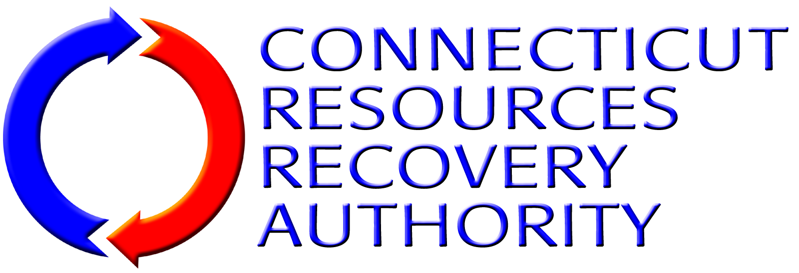
BUSINESS EXCEPTION FORM
Using this form (add additional sheets of paper as needed), SOQ Submitter (hereinafter collectively referred to as “Consultant”) shall identify any portion of the Work required or described in the RFQ Package Documents, or any provision of the Agreement that Contractor desires to take exception to, including insurance, if any.
Contractor shall be specific regarding any exceptions listed. Contractor shall describe in detail the portion(s) of the Work or Agreement terms that the Contractor is taking exception to and why. Contractor shall also describe what, if any, alternative services, terms, or conditions Contractor is willing to provide or accept as a substitution for the Service, terms, or conditions to which Contractor has taken exception, if any.
If Contractor does not take exception to any portion of the Work required or described in this RFQ Package Documents or to any terms of the Agreement, Contractor shall simply indicate below that Contractor “takes no exceptions”, and submit this form along with the other Proposal forms as part of its Proposal submittal.
Note that CRRA will negotiate with Consultant on only those items identified by Consultant on this Business Exception Form. Also note that revisions to the services or Agreement will be at CRRA’s sole discretion. Also note that pursuant to State of Connecticut statutes and regulations, the Agreement contains a number of provisions that CRRA, as a quasi-public entity, is required to incorporate in all of its contracts and are, therefore, non-negotiable.
Description of Exception Item |  | Reason for Exception | Proposed Alternative
1.
2.
3.
4.
5.
6.
7.

